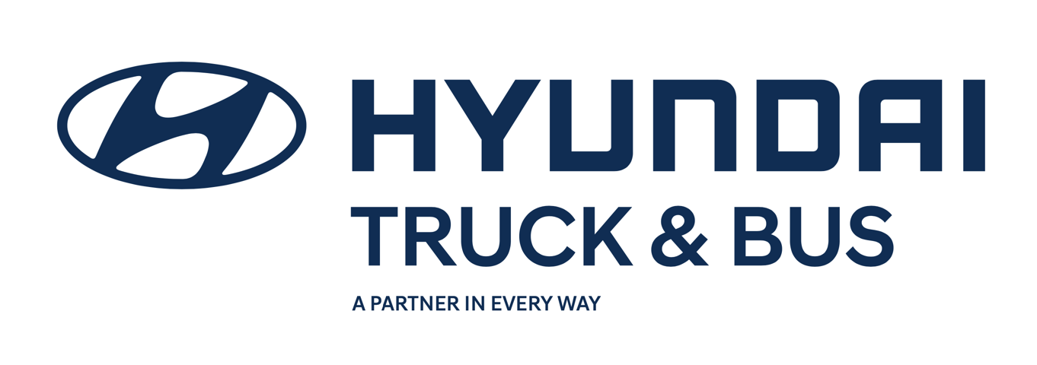

Application
for
Hyundai Commercial Vehicles Franchise

Applicant
Town/Suburb/City
State
Date

Sales, Service & Parts
Parts & Service Only
Hyundai Commercial Vehicles Australia guarantees that all the information provided in this application will be treated as strictly confidential. The submission of this application does not constitute a commitment between the applicant and Hyundai Commercial Vehicles Australia.
Wrong or false information shall be grounds for the termination of any future agreement with Hyundai Commercial Vehicles Australia.

Section 1 – Business Details – Applicant
Please attach the following to this application (as applicable)
1. Corporate Family Tree/Organization Ownership Chart -attached: Yes / No
2. Executive Summary and Corporate profile (if available) -attached: Yes / No
3. Facilities Profile (i.e. maps of buildings, dimensions and pictures) -attached: Yes / No
4. Audited Financial Statements for previous 2 years trading -attached: Yes / No
5. Confirmation letter from floor plan provider -attached: Yes / No

Proposed locations of dealership(s):
1.
2.
3.
Company Information:
Company Name
ACN/ABN
Registered Trading Name
Principle Business Address
Registered Office
Postal Address
Company Website Address
Email |  |  | Phone
Dealer License Number |  |  | License Holder
Type of Ownership:
Pty Ltd Company |  | Partnership |  | As trustee for (if applicable)
Public Company |  | Sole trader |  | Copy of Trust Deed attached

Primary Contact person:
Name
Address
Phone |  | Email
Company Directors or Partners:
Name
Address
Phone |  | Email

Name
Address
Phone |  | Email

Name
Address
Phone |  | Email

Name
Address
Phone |  | Email

Accountant (who can provide financial statements):
Name
Address
Phone |  | Email

Solicitor / Professional Advisor:
Name
Address
Phone |  | Email
Existing Automotive Brands sharing the proposed locations
Name | Location | Type (i.e Full Line / P&S only)
Affiliated automotive agencies sharing the proposed locations
(i.e authorized Allison service point/Cummins agent/Bosch agent/NRMA/RACQ/RACV etc)
Brand | Location | Type (i.e Service/Sales & Service)

Section 2 – Dealership
Dealer Principal
Financial Controller
Sales Manager
Service Manager
Parts Manager
Marketing Manager
Warranty Manager

Total number of employees?
How many New Vehicle Consultants?
How many Parts Sales Consultants? (inc field reps)
How many Service Advisors?
How many qualified Diesel Technicians?
Do you have a dedicated Training Manager or Department?
How many apprentices do you employ?
How many Warranty Administrators do you employ?

How many staff will be dedicated to Hyundai Trucks business?
Department | # | Shared role Y/N | Other Brands
New Truck Sales
Spare Parts
Technicians
Admin (inc Warranty/Marketing)
Are you planning on employing new people dedicated to Hyundai Trucks business?
Department & Role | #
Premises:
sqm
Y/N
Y/N
How many square metres is the total area of the proposed premises?
How many square metres is the building?
Do you have an external area to display Hyundai Trucks?

Do you have an internal area to display Hyundai New Truck POS?

Do you have an internal area to display Hyundai Truck Parts POS?

Does your workshop have space to accommodate LD Hyundai Trucks? Yes / No
Does your workshop have space to accommodate MD/HD Hyundai Trucks? Yes / No
Is your workshop able to service a prime mover without de-coupling? Yes / No
How many service bays does your workshop have?
How many maintenance pits/semi scissor lifts does your workshop have?
How many vehicle lifts suitable for 7t vehicles does your workshop have?
Do you operate a breakdown vehicle for 24hr assistance?
Do you have a secure storage area for warranty or retail repair parts?

Do you have a suspension / brake tester to perform compliance checks?

What other specialised service equipment do you offer customers?

$

What is your current Retail Labor Rate (GST excluded)?

Do you know the Retail Labor Rate of the main competitors in your area?
Brand | $ Rate | Brand | $ Rate

Systems Utilised

What Dealer Management System (DMS) do you operate?

What Enquiry Tracking / Lead Management System do you operate?

Do you operate a separate CRM System?

Approximately how many customers do you have in your CRM?

Please provide details of any dealership recognition/achievement awards (including other brands or community activities)
Manufacturer Awards/Recognition

Community Awards/Recognition

SWOT Analysis
Please provide a brief SWOT analysis of your dealership, market area, organization along with any improvements or future plans for the business

Strengths | Weaknesses
Opportunities | Threats

Recovery activities/plans for Weaknesses & Threats

Are you planning any facility upgrades or expansion in the next year?
Provide brief details on estimated expenditure for facility upgrades and timing of development.

What is the status of the property where the dealership is located?
Owned/mortgaged as part of the company or group
Leased from an independent party
If leased, terms and length of lease

Section 3 – Financial Information & References
Security over Business? (i.e. PPSR Registrations List) Yes / No
Security provider and type of charge

Current Floor Plan Providers
Provider | Business/Brand | Approved Limit
Other Financial Providers
Provider | Type of Funding | Approved Limit

How much floor plan will you provide for Hyundai Trucks?

New Trucks | $
Spare Parts | $

Retail Finance Providers

Do you have Business Managers/Brokers in the dealership? Yes / No

Do you have an external Broker you utilize? Yes / No

Trade References
Name
Address
Phone |  | Email
Monthly Spend | $

Name
Address
Phone |  | Email
Monthly Spend | $

Please also forward written confirmation of floor financing from your financing company.

Declaration

I declare that all the information provided in this application is true and correct.

It is declared and acknowledged that Hyundai Commercial Vehicles Australia (HCVA) Pty Limited has the absolute right and discretion to appoint as a dealer such person/s as it considers to be appropriate.

This application will be kept in the strictest confidence until HCVA has assessed, approved and, if applicable, informed the incumbent dealer of our decision in the proper manner. HCVA makes no representation or warranties about potential profitability of possible franchises. Should your application be successful you will be provided with a Disclosure Document in accordance with the Franchise Code of Conduct.

Signed ……………………………….

Applicant Name ………………………

Date ……………………………….

